**Diana Melendez**

**September 5, 2021**

**Weather API Data Analysis**

**Objective:** Analyze weather related to Latitude versus Temperature, Humidity, Cloudiness and Windspeed.

**Data Overview:** Our data contains weather information pertaining to 500 cities. The data variables include the city, country, latitude, longitude, temperature, wind, pressure and humidity.

**Data Insights:**

Based on the latitude and temperature plots, there is a positive correlation with the temperature being higher the closer you are to zero-degree latitude (at the equator). There is also a negative correlation between latitude and temperature with temperatures being lower the farther north toward higher latitudes such as 60-80 degrees latitude. Another observation is that the windspeeds are higher in the Northern Hemisphere while the windspeeds are lower and more moderate in the Southern Hemisphere. The following pages give in depth analysis for Northern and Southern Hemisphere based on the variables of temperature, wind, pressure and humidity.

**Call to Action:** I recommend that the most likely location to plan a vacation would be in the Southern Hemisphere at about 10-20 degrees latitude to optimize the humidity, temperature and windspeeds as reflected in the regression models.

**Wind Speed – Northern VS Southern Hemisphere**

The windspeeds are higher in the Northern Hemisphere while the windspeeds are lower and more moderate in the Southern Hemisphere.

Heatmap Northern Hemisphere

According to the heatmap for the Northern Hemisphere, there is a strong negative correlation between the temperature and the latitude reflecting in cooler temperatures. There is also a slightly negative correlation between Temperature and Humidity.

Heatmap Southern Hemisphere

According to the heatmap for the Southern Hemisphere, there is a negative correlation between the Temperature & Humidity as well as Pressure and Latitude resulting in a less humid environment.

There is a positive correlation between Latitude and Temperature resulting in warmer temperatures.

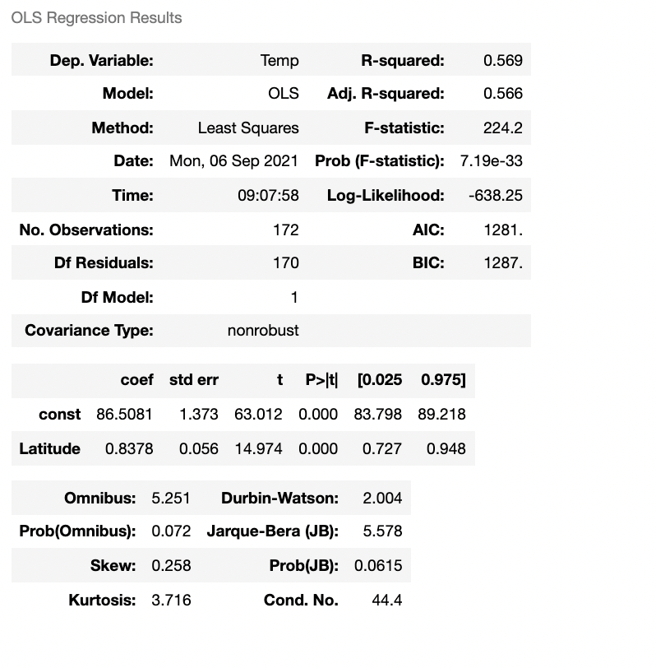

There is a negative correlation between latitude and temperature. The higher the latitude, the lower the temperature.

Northern Regression – Temp vs Latitude

Southern Regression – Temp vs Latitude

There is a positive correlation between temperature and latitude. There is an increase in temperature the closer to zero-degree latitude (at the equator).

Northern Regression – Humidity vs Latitude

There is a positive correlation between Humidity and Latitude. This shows a higher humidity in the Northern Hemisphere.

Southern Regression – Humidity vs Latitude

There is a slightly negative correlation between Humidity and Latitude in the Southern Hemisphere. This shows a lower humidity the closer to zero-degree latitude at the equator.

Northern Regression – Wind vs Latitude

There is a slightly positive correlation between Wind Speed and Latitude in the Northern Hemisphere. This shows a slight increase in wind speed the higher the latitude.

Southern Regression – Wind vs Latitude

There is a slightly negative correlation between Wind Speed and Latitude in the Southern Hemisphere. This shows a slight decrease in wind speed the higher the closer to zero-degree latitude at the equator.

There is a higher windspeed variance between the 40-80 degree latitudes with more moderate wind speeds below the 40-degree latitude line.

There is a high level of cloudiness evenly spread throughout the northern hemisphere with the cloudiness being slightly higher (80-100%) above the 40-degree latitude line. There is also a slightly lower variance of cloudiness below the 0-degree latitude line at the equator and below.